Rachel Flynn

CS 110 Project

Dr. Ryan

13 December 2020

**“Overview and Summary of Project”**

* The purpose of my program is to enable the user to determine the highest performing stock in a certain sector (during the pandemic), which is displayed through a graph which charts the closing prices of stocks in that sector. This is accomplished through providing the user with a list of three sectors in the stock market to choose from, and the program will return the corresponding graph of the closing prices of the ten biggest companies of that sector from 12/02/2019 to 11/27/2020 for whichever number is entered. The user interface of this program would be best described as asking the user to input a number from one to three which corresponds to a certain sector, and the output is the corresponding graph of stocks for that sector. If the user enters an invalid number or a non-numerical character, the program will return an error.
  + Snapshot of User Interface:

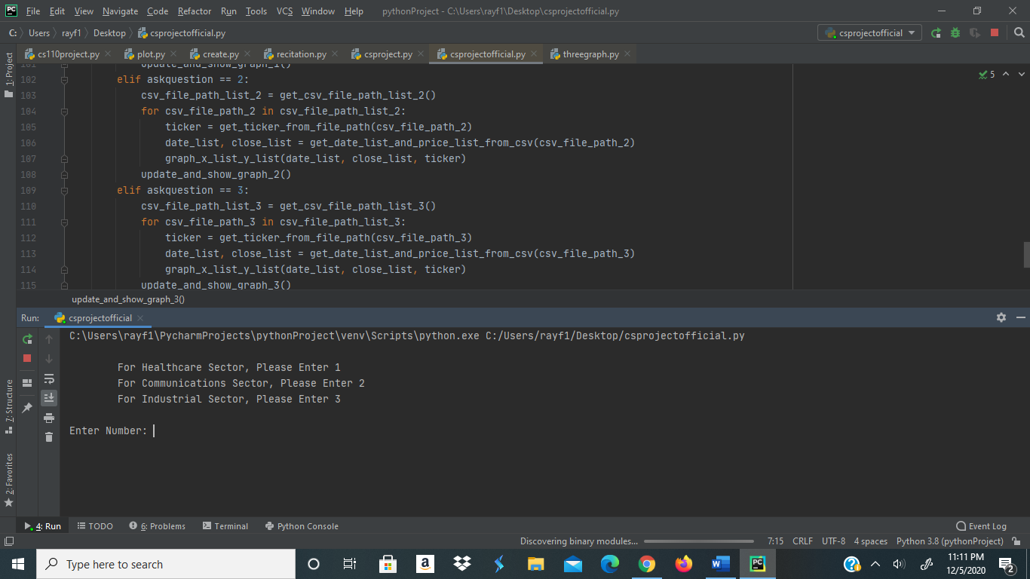

* + Sample Input: If the user enters 1
  + 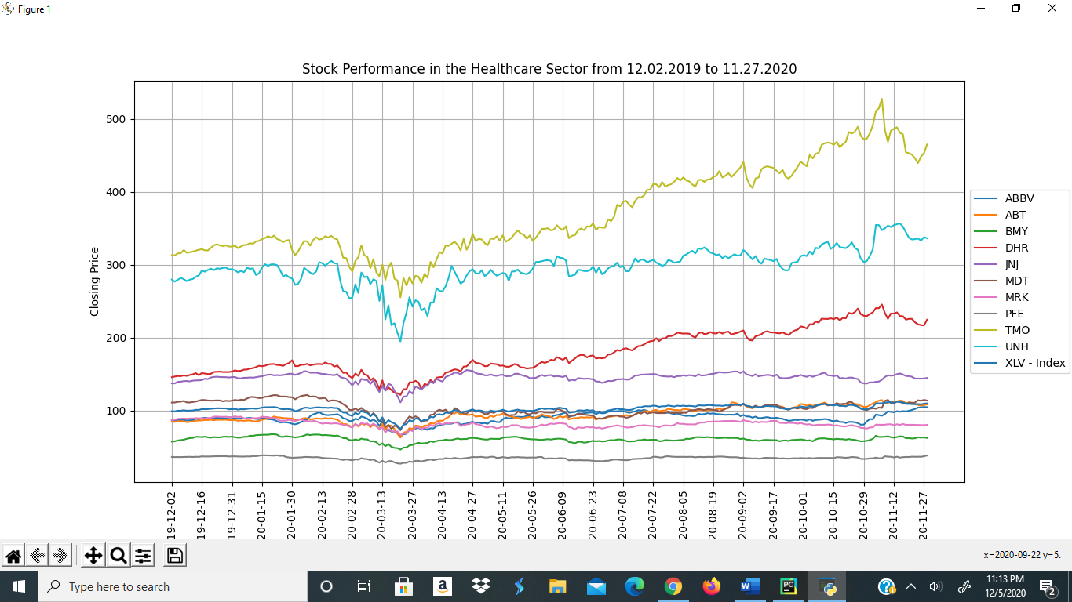Sample Output: The graph of the healthcare sector

**“Target Audience”:**

* The intended audience of this program would be anyone who is interested in investing or evaluating the performance of stocks in the healthcare, industrial, or communications sectors. The output of this program provides the user with the closing prices of stocks in certain sectors over the past year, which have all been heavily impacted by the coronavirus pandemic, and allows the user to determine which stocks are possible value plays or growth stocks. The sector index has also been plotted which provides a baseline for which stocks have overperformed or underperformed. Therefore, whoever uses this program would be able to analyze the probable performance of a stock in a certain sector.

**“Specific Programming Techniques Used”:**

* The initial programming technique that is utilized in my program is exception handling with try-except statements, which returns an error if the user enters a non-numerical character. Also, I used if-elif-else statements for the user’s input of a number from the list that they are shown, which returns the healthcare sector if the user enters one, the communications sector if the user enters two, and the industrial sector if the user enters three. If the user does not enter any of these numbers, the program returns an error for an invalid number. I also utilized functions in my program to collect information from files, which I created and stored stock information in, to define the parameters and information for the graphs that were displayed, and to return information from the csv files for stocks that were graphed. The data was collected from Yahoo Finance and analyzed by using for loops which extracted the date and closing prices for each day of the year of each stock in the folders.

**“Challenges”:**

* The major challenge that I encountered during my design was trying to figure out how to plot a graph that was visually appealing. Initially, the dates of each stock on the x axis were overlapping each other and were unable to be understood. Also, the legend was overlapping the graph and some of the plotting was obstructed. I was able to fix the x axis of the graph through setting an interval for the number of dates that were displayed, which reduced the number of dates that appeared on the axis. I was able to resolve the legend issue through setting the location of it to the center left of the graph and setting the location of the legend on the x and y axis.
* **“Future Extensions”:**
  + Possible Improvements: I would add a feature to the program which returns a subplot of the volume of each stock in a sector, in addition to a plot of the closing prices of each stock. This would provide better context as to why certain stocks are being traded, or why certain stock prices have fallen or risen drastically on a certain day. Ideally, I would like for the graphs to be returned at the same time and possibly stacked on each other.
  + Possible Extensions: I think that this program could be extended through the addition of multiple sectors which would provide the user with additional information from different stocks and how they have performed during the pandemic.

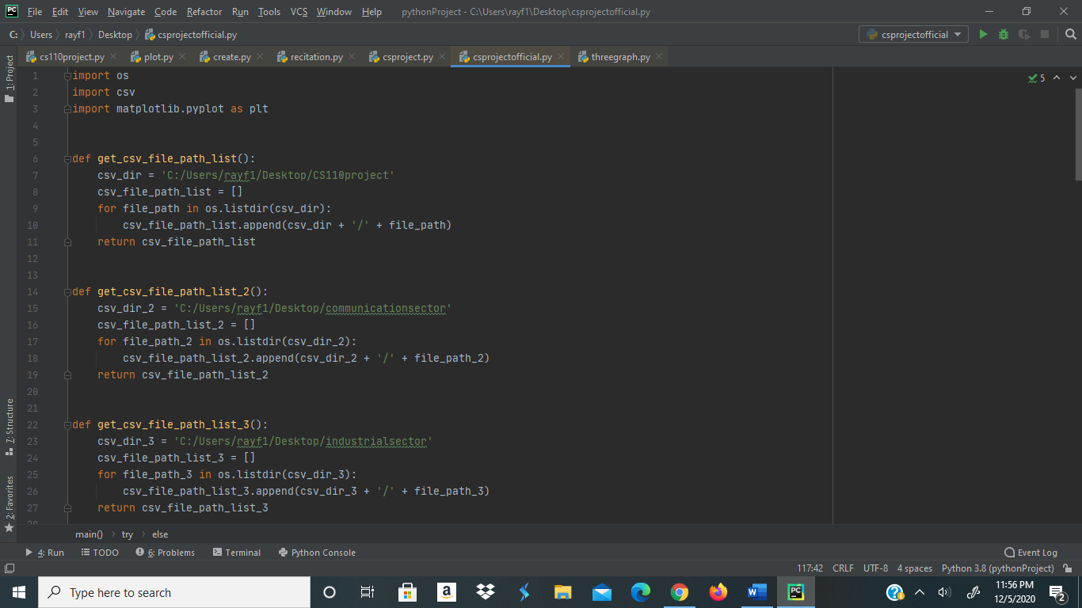**Code:**

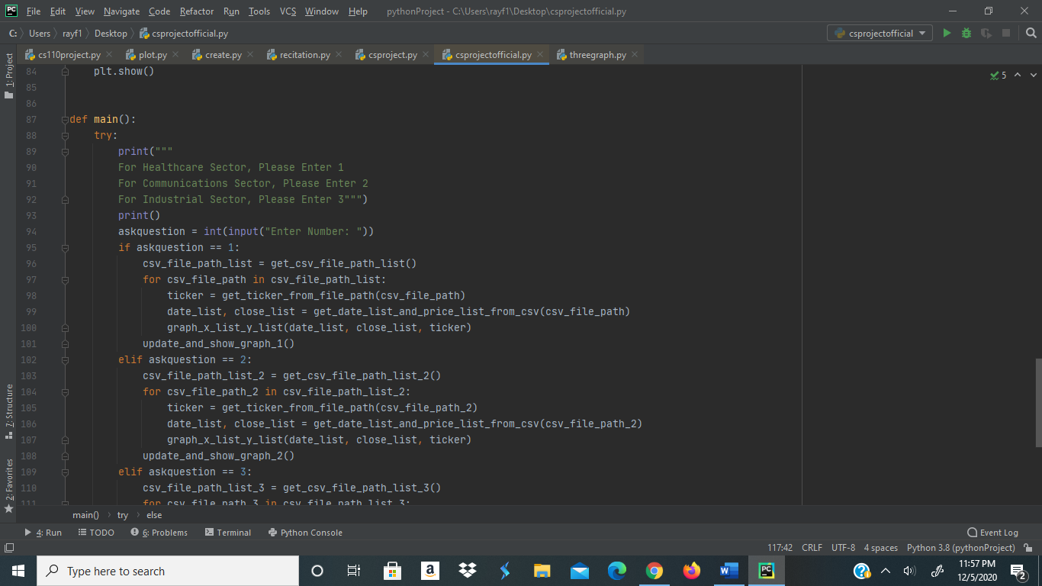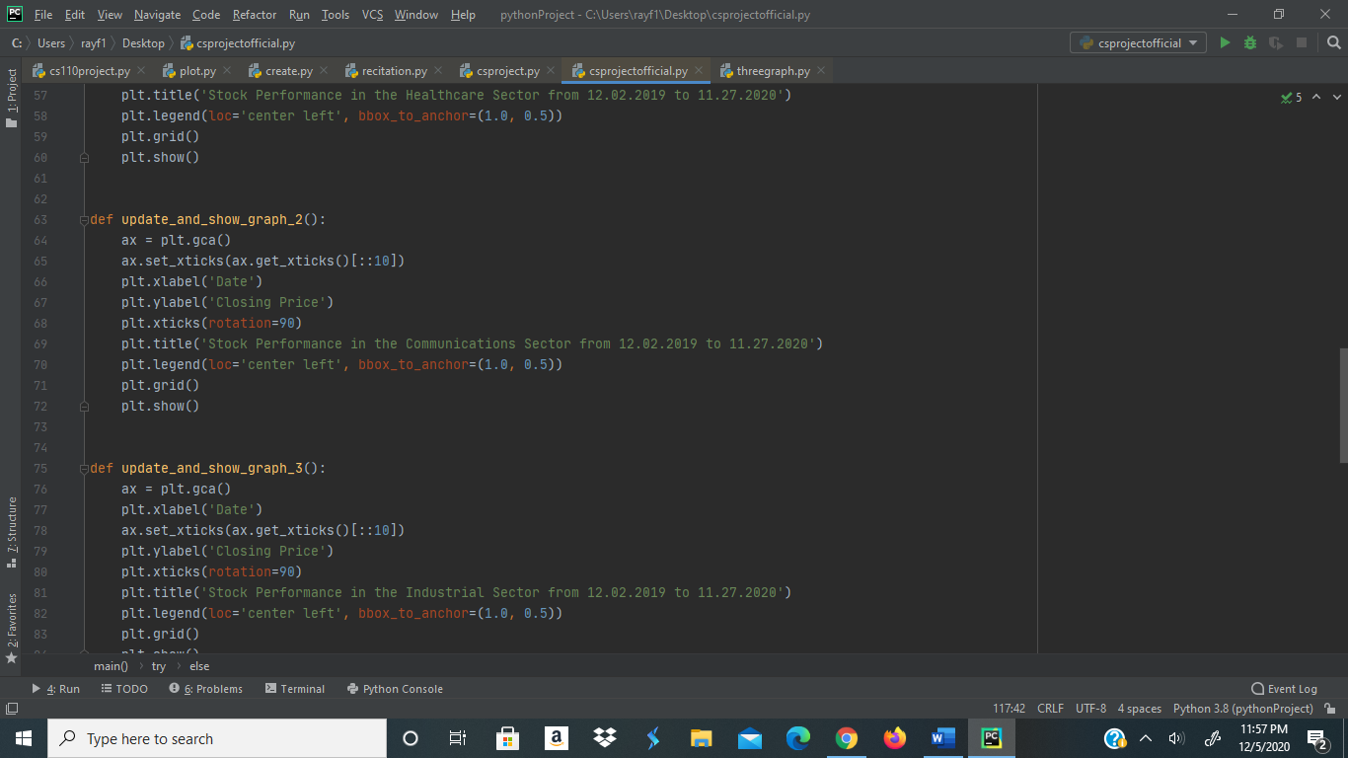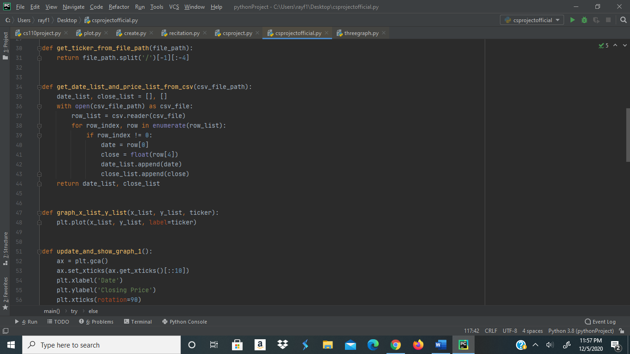

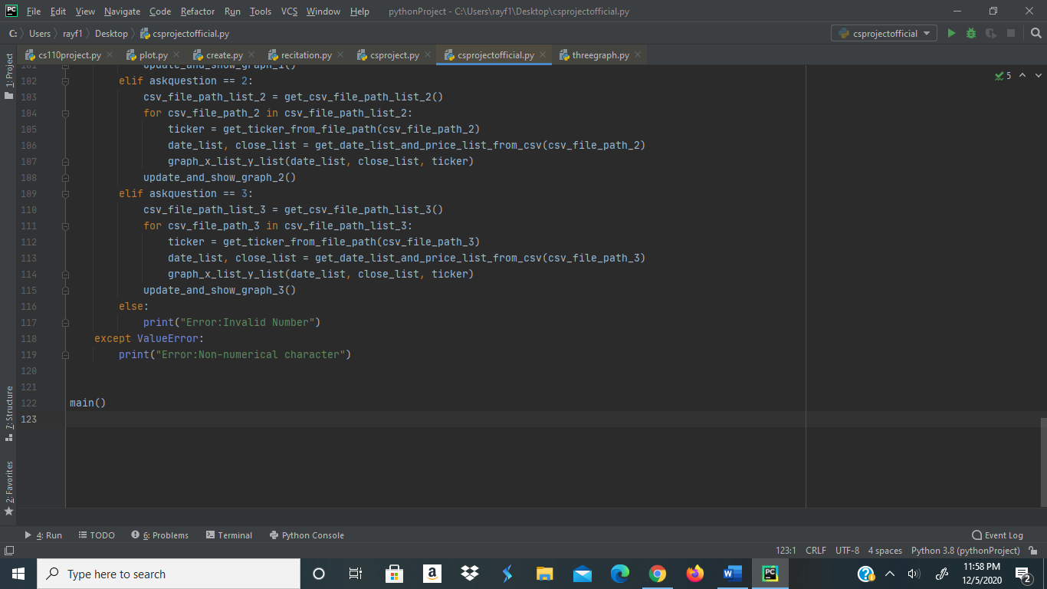

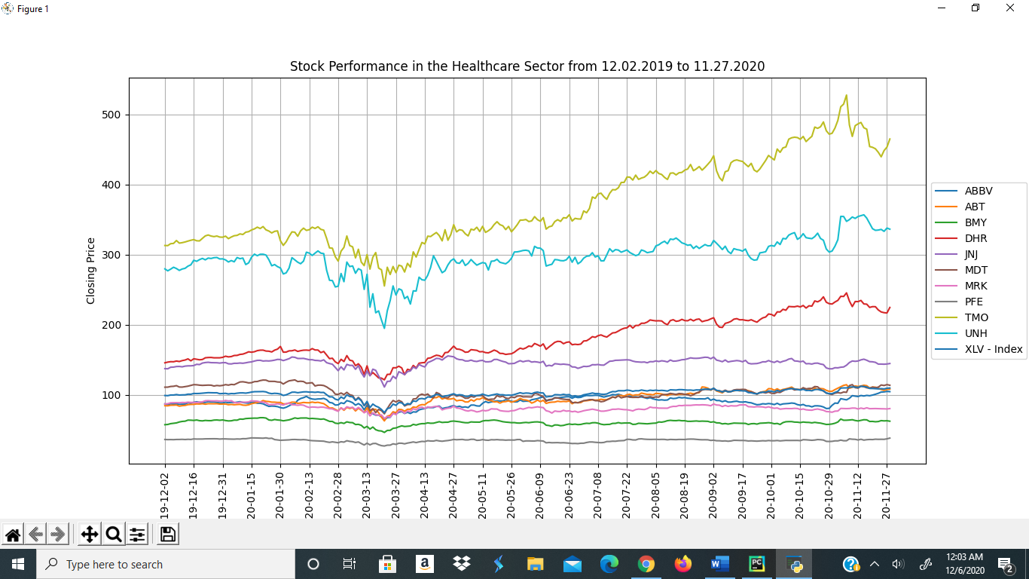**Output:**

